

**International School**

**Capstone Project 1**

CMU-SE 450

**Database Design Document**

**Version 1.1**

**Date:** 14-Mar-2022

**Medical notebook**

**Submitted by**

**Trang, Le Thi Huyen**

**Tuan, Le Van**

**Tuong, Tran Dinh Viet**

**Triet, R’com**

**Cong, Pham Hoang**

**Approved by Tran Thi Thuy Trinh**

# **Project Information**

|  |  |  |  |  |
| --- | --- | --- | --- | --- |
| **Project acronym** | MNS | | | |
| **Project Title** | Medical Notebook System | | | |
| **Start Date** | 10-Feb-2022 | **End Date** | 15-May-2022 | |
| **Lead Institution** | International School, Duy Tan University | | | |
| **Project Mentor** | Trinh, Tran Thi Thuy M.Sc.  Email: [thuytrinh85@gmail.com](mailto:thuytrinh85@gmail.com) | | | |
| **Scrum master / Project Leader & contact details** | Le Thi Huyen Trang  Email: lethihuyentrang26042000@gmail.com  Tel: 0376547267  ID: 24207115849 | | | |
| **Partner Organization** |  | | | |
| **Project Web URL** |  | | | |
| **Team members** | Name | Email | | Tel |
| 24211207229 | Tuan, Le Van | Tuanletk1@gmail.com | | 0865558065 |
| 24211205304 | Cong, Pham Hoang | 18hcong@gmail.com | | 0963275441 |
| 24211206525 | Hung, Van Si | [Vansihunginfo@gmail.com](mailto:Vansihunginfo@gmail.com) | | 0353452555 |
| 24211208566 | Tuong, Tran Dinh Viet | trandinhviettuong2000@gmai.com | | 0368053223 |
| 24211208352 | Triet, R’com | bombom2k@gmail.com | | 0344256100 |

# **Database Design Document**

|  |  |  |  |  |
| --- | --- | --- | --- | --- |
| Document Title | Database Design Document | | | |
| Reporting Period | 15-May-2022 | | | |
| Author(s) | All members, Scum master | | | |
| Role | Developer | | | |
| Date | 12-Mar-2022 | FileName | C1SE.07_DatabaseDesign_MNS | |
| Mentor | Trinh, Tran Thi Thuy | | Signature: |  |
| Date: |  |
| Scrum Master | Trang, Le Thi Huyen | | Signature: |  |
| Date: |  |
| Team Members | Tuan, Le Van | | Signature: |  |
| Date: |  |
| Cong, Pham Hoang | | Signature: |  |
| Date: |  |
| Tuong, Tran Dinh Viet | | Signature: |  |
| Date: |  |
| Triet, R’Com | | Signature: |  |
| Date: |  |

|  |  |  |
| --- | --- | --- |
| **Document History** | | |
| **Version** | **Date** | **Comments** |
| V1.0 | 12-Mar-2022 | Create Database Design |
| V1.1 | 14-Mar-2022 | Update Database Design 2. |

**TABLE OF CONTENT**

**Project Information** 1

**Database Design Document** 2

**1.** **Introduction** 4

**1.1.** **Purpose** 4

**1.2.** **Goal** 4

**1.3.** **Scope** 4

**1.4.** **Data storage platforms** 5

**1.5.** **Definition, Acronyms and Abbreviations** 5

**2.** **Database Design** 5

**2.1.** **Table Overview** 5

**2.2.** **Entity Relationship Diagram** 6

**2.3 Table Relationship Diagram** 7

**2.4.** **Detail** 8

**3.References** 12

# **Introduction**

## **Purpose**

Place information system’s database design document describes structure of database and file structure of system. Database Design document will introduce all attribute the System that will help developer and tester base on this design to implement and test.

## **Goal**

To create database tables most accurate.

## **Scope**

This Database Design Document provides the basic for “MNS” Database design.

It describes both logical and physical definition, non-functional issues, and the database interfaces; storage aspects are defined in the physical database design sections.

The tables performance considerations requirements. The following topics are covered in this document:

* Assumptions and decisions on database design.
* Entity-mapping.
* Table column definitions.
* Primary, unique and foreign key definitions.
* Column and row level validation rules (check constraints).
* Rule for populating specific columns (sequences, derivations, demoralized (column)).
* Interfaces and dependencies with other components.
* Data access description.

The database design is composed of definitions for database objects derived by mapping entities to tables attributes to columns, unique identifiers to unique keys and relationships to foreign keys.

During design, these initial definitions are enhanced to support the functionality described in the functional specification/ user stories and defined in the primary and supporting modules of the application high level design.

## **Data storage platforms**

Data of application is stored in PostgreSQL database.

In PostgreSQL, data structure is stored as tables that the database objects that behave as containers for the data, in which the data will be logically organized in rows and columns format.

## **Definition, Acronyms and Abbreviations**

**Table 1**: Details of PK/FK & ERD

|  |  |  |
| --- | --- | --- |
| **Abbreviations** | **Description** | **Comment** |
| PK/FK | Primary/ Foreign Key | Use to indicate a file is a Primary or Foreign key in a table |
| ERD | Entity Relationship Diagram | Show the relationship between entities in the system |

## **Database Design**

## **Table Overview**

**Table 2**: Details of Table Overview

|  |  |  |
| --- | --- | --- |
| **No.** | **Table name** | **Short Description** |
| 1 | users |  |
| 2 | medical_histories |  |
| 3 | profile_after_vaccinations |  |
| 4 | roles |  |
| 5 | staff_injection |  |
| 6 | vacc_order_register |  |
| 7 | address_injections |  |
| 8 | sympton |  |
| 9 | vaccinations |  |
| 10 | address_injection_vacc |  |
| 11 | wards |  |
| 12 | districts |  |

## **Entity Relationship Diagram**

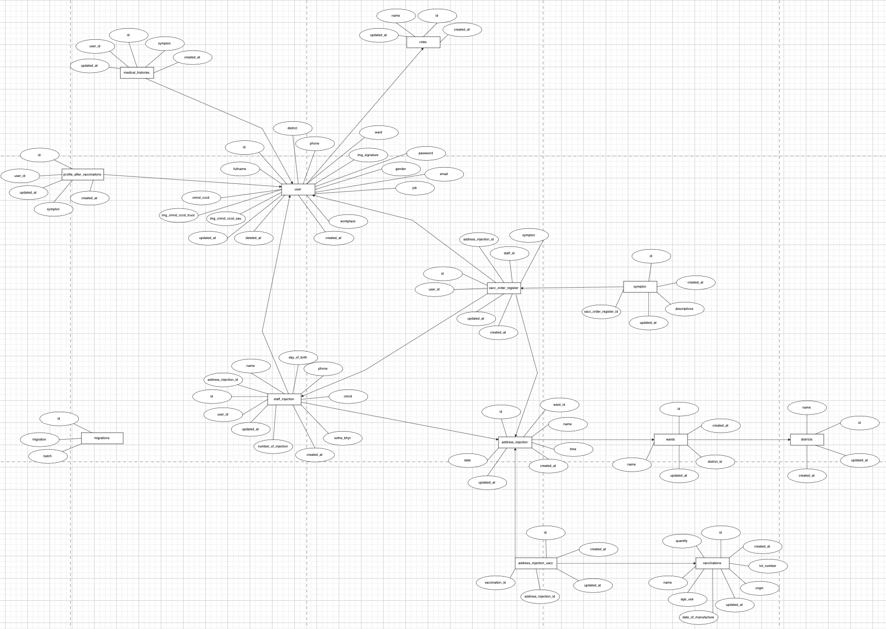

**Figure 1**: Entity Relationship Diagram

## **2.3 Table Relationship Diagram**

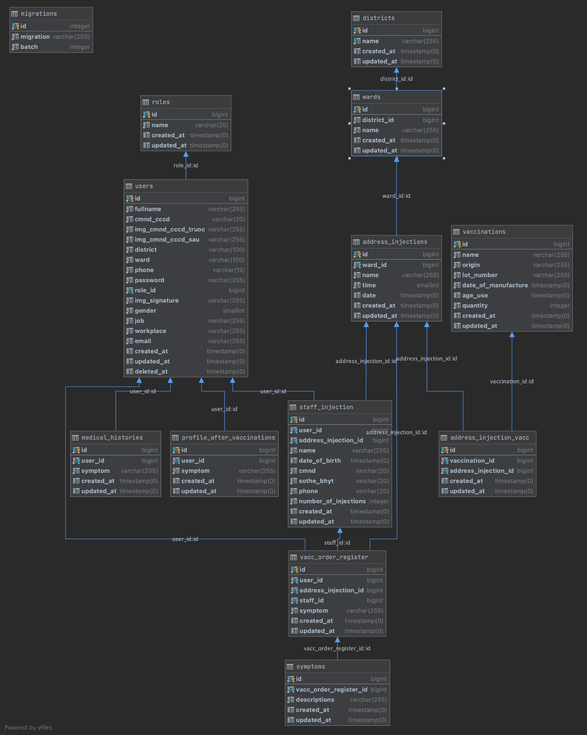

**Figure 2**: Relationship Diagram

## **Detail**

* + 1. **Users**

**Table 3**: Details of Users

|  |  |  |  |  |  |
| --- | --- | --- | --- | --- | --- |
| **Attributes** | **Datatype** | **Null** | **Key** | **Default** | **Extra** |
| id | bigint | NotNull | Pk |  | user's id |
| fullname | varchar(255) |  |  |  | user's first and last name |
| cmnd_cccd | varchar(20) |  |  |  | identity card number or citizen identification |
| img_cmnd_cccd_truoc | varchar(255) |  |  |  | photo of identity card first |
| img_cmnd_cccd_sau | Varchar(255) |  |  |  | photo of the following identity card |
| district | Varchar(100) |  |  |  | District |
| ward | Varchar(100) |  |  |  | address |
| phone | Varchar(15) |  |  |  | phone number |
| role_id | bigint |  |  |  | authorization id |
| password | Varchar(255) |  |  |  | password |
| img_signature | Varchar(255) |  |  |  | signature photo |
| gender | smallint |  |  |  | **Male/ Female** |
| job | varchar(255) |  |  |  | Work |
| workplace | varchar(255) |  |  |  | Workplace |
| email | varchar(255) |  |  |  | user email |

* + 1. **Medical histories**

**Table 4**: Details of Medical histories

|  |  |  |  |  |  |
| --- | --- | --- | --- | --- | --- |
| **Attributes** | **Datatype** | **Null** | **Key** | **Default** | **Extra** |
| id | bigint | Not Null | primary key |  | medical history id |
| user_id | bigint |  |  |  | user id |
| symptom | varchar(255) |  |  |  | symptom |

* + 1. **Profile after vaccination**

**Table 5**: Details of Profile after vaccination

|  |  |  |  |  |  |
| --- | --- | --- | --- | --- | --- |
| **Attributes** | **Datatype** | **Null** | **Key** | **Default** | **Extra** |
| id | bigint | Not Null | primary key |  | medical history id |
| user_id | bigint |  |  |  | user id |
| symptom | Varchar(255) |  |  |  | symptom |

* + 1. **Role**

**Table 6**: Details of Role

|  |  |  |  |  |  |
| --- | --- | --- | --- | --- | --- |
| **Attributes** | **Datatype** | **Null** | **Key** | **Default** | **Extra** |
| id | bigint | NotNull | Primary key |  | authorization id |
| name | Varchar(20) |  |  |  | authorized name |

* + 1. **Staff injection**

**Table 7**: Details of Staff injection

|  |  |  |  |  |  |
| --- | --- | --- | --- | --- | --- |
| **Attributes** | **Datatype** | **Null** | **Key** | **Default** | **Extra** |
| id | bigint | Notnull | Primary key |  | injection confirmation id |
| user_id | bigint |  |  |  | user id |
| address_injection_id | bigint |  |  |  | vaccine id |
| date_of_birth | timestamp(0) |  |  |  | the expiration date of the vaccine |
| cmnd | varchar(20) |  |  |  | vaccine production site |
| sothe_bhyt | varchar(20) |  |  |  | injection confirmation photo |
| phone | varchar(20) |  |  |  | id number of injections |
| number_od_injections | integer | Notnull | Foreign key |  |  |

* + 1. **Vacc order register**

**Table 8**: Details of vacc order register

|  |  |  |  |  |  |
| --- | --- | --- | --- | --- | --- |
| **Attributes** | **Datatype** | **Null** | **Key** | **Default** | **Extra** |
| id | bigint | NotNull | Primary key |  | id number of injections |
| user_id | bigint |  |  |  | name |
| address_injection_id | bigint |  |  |  | vaccine id |
| staff_id | bigint |  |  |  |  |
| sympton | varchar(255) |  |  |  |  |

* + 1. **Address injections**

**Table 9**: Details of Address injections

|  |  |  |  |  |  |
| --- | --- | --- | --- | --- | --- |
| **Attributes** | **Datatype** | **Null** | **Key** | **Default** | **Extra** |
| id | bigint | NotNull | Primary key |  | id of injection address |
| ward_id | bigint |  |  |  | id of the area |
| name | varchar(255) |  |  |  | injection address name |
| time | smallint |  |  |  | time |
| date | timestamp(0) |  |  |  | date of injection |

* + 1. **Symptom**

**Table 10**: Details of Symptom

|  |  |  |  |  |  |
| --- | --- | --- | --- | --- | --- |
| **Attributes** | **Datatype** | **Null** | **Key** | **Default** | **Extra** |
| id | bigint | NotNull | Primary key |  |  |
| vacc_order_register_id | bigint |  |  |  |  |
| descriptions | varchar(255) |  |  |  |  |

* + 1. **Vaccinations**

**Table 11**: Details of Vaccinations

|  |  |  |  |  |  |
| --- | --- | --- | --- | --- | --- |
| **Attributes** | **Datatype** | **Null** | **Key** | **Default** | **Extra** |
| id | bigint | NotNull | Primary key |  |  |
| name | varchar(255) |  |  |  | batch number of vaccine |
| lot_number | varchar(255) |  |  |  |  |
| date_of_manufacture | timestamp(0) |  |  |  |  |
| age_use | timestamp(0) |  |  |  |  |
| quantity | integer |  |  |  |  |

* + 1. **Address injection vacc**

**Table 12**: Details of Address injection vacc

|  |  |  |  |  |  |
| --- | --- | --- | --- | --- | --- |
| **Attributes** | **Datatype** | **Null** | **Key** | **Default** | **Extra** |
| id | bigint | NotNull | Primary key |  |  |
| vaccination_id | bigint |  |  |  |  |
| address_injection_id | bigint |  |  |  |  |

* + 1. **Wards**

**Table 13**: Details of wards

|  |  |  |  |  |  |
| --- | --- | --- | --- | --- | --- |
| **Attributes** | **Datatype** | **Null** | **Key** | **Default** | **Extra** |
| id | bigint | NotNull | Primary Key |  | medical staff id |
| name | varchar(255) |  |  |  | name |
| district_id | bigint |  |  |  | District |

**2.4.11 Migrations**

**Table 13**: Details of migraitons

|  |  |  |  |  |  |
| --- | --- | --- | --- | --- | --- |
| **Attributes** | **Datatype** | **Null** | **Key** | **Default** | **Extra** |
| id | integer | NotNull | Primary Key |  |  |
| migration | varchar(255) |  |  |  |  |
| batch | integer |  |  |  |  |

# **3.References**

[1] [CMSERD](https://drive.google.com/file/d/1UHSXdYazFPREu2oOqvYzvNGF32LF-ZsW/view?fbclid=IwAR2JAec0epCWo9fgQDsLqGrEqE-QlV9boEqREhxF4IyA5qTJdjRiorA3Rgc)